Prince Edward County Jazz Festival
Aug. 11 - 16
Fifteen Years in ’15!

The Music of Miles Davis and Billie Holiday -
Oliver Jones - Guido Basso – Shakura S’Aida -
Brian Barlow Big Band and “the best of the best”

The little festival that has grown into one of Canada’s most respected celebrations of jazz is fifteen years old this summer.

Today, we announce a 2015 lineup of main-stage shows featuring an array of A-list artists pouring out a wide range of jazz that live music-lovers will simply not want to miss.

We are proud to announce that three of the last five winners of the “Rising Young Star” award…Marika Galea, Ian Wright and Eli Bennett…will perform in main-stage shows. Marika and Ian are also graduates of the Festival’s TD Jazz Education Program.

As usual, the festival will showcase some of the world’s best musicians from Toronto, Montreal, Vancouver, and south of the border. Festival-goers can also savour great jazz, great food, and great wine at many of the 30 satellite venues nestled throughout the “County” all week long.

Detailed schedule and ticket information at www.pecjazz.org

Main Stage Performances

Wed. Aug. 12 - The Bob DeAngelis Quintet - 6:00 p.m. Huff Estates Winery
The double-JUNO winner leads an all-star fivesome in the festival’s kick-off Jazz Dinner

Thurs. Aug. 13 - Miles Davis’ “Kind of Blue” - 8:00 p.m. Regent Theatre
Trumpeter Steve McDade joins saxophonist Remi Bolduc, bassist Jodi Proznik and former festival Rising Young Stars Ian Wright and Eli Bennett in a recreation of Miles Davis’ landmark album

Fri. Aug.14 - Guido Basso and Shakura S’Aida - 8:00 p.m. Regent Theatre
The world’s foremost flugelhornist with Canada’s soulful singer-citizen of the world

Sat. Aug. 15 – Tribute to Billie Holiday – Marika Galea Quartet
2:00 p.m. St. Mary Magdalene Church, Picton
The festival’s 2014 Rising Young Star returns, direct from the jazz clubs of Boston

Sat. Aug. 16 – Oliver Jones Quartet - 8:00 p.m. Regent Theatre
Canada’s iconic pianist with brothers Chet and Jim Doxas

Sun. Aug. 17 - Brian Barlow Big Band - The Best of the Best
8:00 p.m. Regent Theatre
The “big band best” of the festival’s 15 years – the music of Rob McConnell, Ellington, Basie, and Goodman

Artist Bios

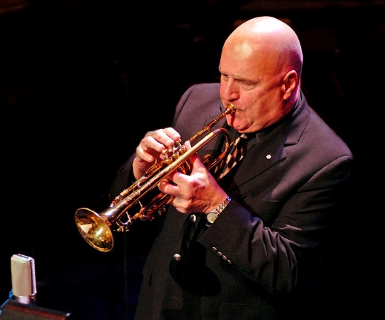 Guido Basso

The Prince Edward County Jazz Festival is proud to consider its long association with Guido Basso (the festival’s artist-in-residence) a part of its DNA.
The background: multiple Grammys, Junos, an Order of Canada membership, thirty years and thirty recordings as a charter member of Rob McConnell and the Boss Brass; a teen-aged career that began with crooner Vic Damone on a two-year international tour, and led to three years on the road with Pearl Bailey and her bandleader/husband, drummer Louis Bellson. He’s performed and recorded with them all: Sinatra, Fitzgerald, Gillespie, Herman, Goodman, Ellington, Basie, Ellington, Rich, Krall, and so many more. Canada’s undisputed Minister of Romance on the flugelhorn will play at the Jazz Dinner kickoff and in his own main-stage show with vocalist Shakura S’Aida.

(con’d below)

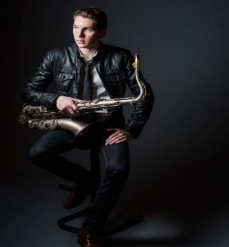 Eli Bennett

Eli was the Festival’s Rising Young Star winner in 2010, and was recently similarly recognized by the Canadian Academy of Recording Arts & Sciences. He’s a two-time winner of the Canadian CBC Galaxie Rising Star Award, and he won the 2012 Vancouver Mayor's Arts Award. For two years in a row, he performed at the Grammy Awards in Los Angeles. He’s also a 2012 Leo Award nominee for his additional music score for Nash – a documentary on the life of basketball legend Steve Nash. He’ll be performing during the Miles Davis Kind of Blue show on August 13th.

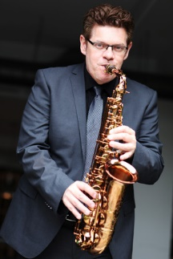 Remi Bolduc

Last year’s festival-goers were particularly riveted by the alto saxophone playing of one of Montreal’s finest, Remi Bolduc, whose role in re-creating Dave Brubeck’s Time Out album and Paul Desmond’s Take Five was a show-stopper. A Charlie Parker devotee and multi-award winner, Remi is a professor of jazz at Montreal’s McGill University. Monsieur Bolduc will provide five-star support for Steve McDade as the trumpeter takes the lead in his re-creation of Miles Davis’ super-album, Kind of Blue.

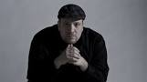 Robi Botos
A frequent performer and warm friend of the festival, Robi Botos once opened for Oscar Peterson (his former mentor), and his stock as an elite, internationally-renowned jazz artist has been climbing ever since. The proof: a 2007 National Jazz Award for Keyboardist of the Year, 2007 NOW Award for Best Jazz Artist and first place prizes at the 2008 Montreux Jazz Festival Solo Piano Competition and 2008 Great American Jazz Piano Competition. Most recently, Robi was awarded the 2012 TD Grand Jazz award at The Montreal International Jazz Festival. Robi will play this year at the Jazz Dinner kick-off, and in the Miles Davis Kind of Blue show.

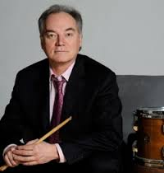 The Brian Barlow Big Band

Over the festival’s 15 years, Sunday nights and big band music have become an almost indispensable tradition. From the music of Rob McConnell and the Boss Brass, to Benny Goodman, to Duke Ellington and Count Basie…the Festival is pleased to present a “best of the best” on Sunday, Aug. 16 at the Regent Theatre. The Barlow outfit is home to some of the world’s best jazz and swing musicians…some having actually played in the bands whose music will be showcased on this night.

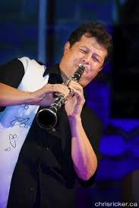 Bob DeAngelis

One of Toronto’s most versatile performers, this Juno winner is considered one of Canada's busiest and most accomplished bandleaders and freelance musicians. Festival fans still talk about his incredible performance on clarinet at last summer’s “Benny Goodman at Carnegie Hall” show at the Regent Theatre. From duos and trios all the way to swingin’ big bands, he’s entertained presidents, prime ministers, and members of the Royal Family. The DeAngelis quintet’s “hot” and “cool” swing and jazz usually starts the toes tappin’ and the fingers snappin’.

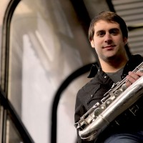 Chet Doxas

Now based in New York, this Montreal born-and-raised musician has firmly positioned himself as a standard-bearer for the new generation of tenor saxophonists. He can be heard on more than a hundred albums, and has shared studios and stages with a wide range of musicians including Guido Basso, Maria Schneider, Joe Lovano, Sam Roberts, Rufus Wainwright, and Oliver Jones, with whom he will play on Saturday Aug. 15 at the Regent Theatre.

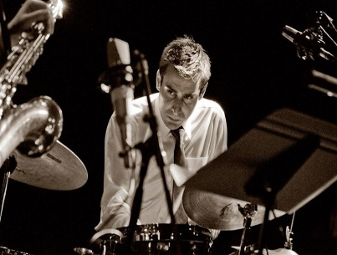 Jim Doxas

Fifteen years into his career as a mainstay on the Montreal jazz scene, Jim Doxas has appeared on about a hundred albums and performs over 200 concerts a year. That includes almost 70 with the revered Oliver Jones, working as his drummer since 2004.
Also a teacher at McGill University, he launched Blind Leap, his first album as a bandleader, in 2014. Add another Oliver Jones performance to his resume after Sat. Aug. 15, when he appears at our festival with brother and tenor saxman Chet alongside Mr. Jones.

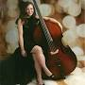 Marika Galea

Marika is last year’s winner of the Festival’s Rising Young Star award, and has established an impressive cross-border career as she studies at Boston’s Berklee College. Since enrolling there, she’s performed everywhere from the desert of Santa Fe to Dizzy’s Club Coca-Cola in New York, and has earned recent recognition for her role as a side-woman with the Cyrus Chestnut Trio. Marika will lead her own quartet in a Tribute to Billie Holiday at 2:00 p.m. on Sat. Aug. 15 at St.Mary Magdalene Church in Picton.

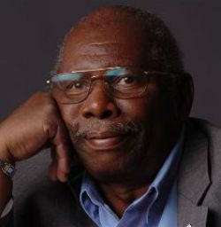 Oliver Jones

Oliver Jones - maybe Canada’s most beloved jazz musician - was inspired early in his six-decade career by the great Oscar Peterson. Admired throughout the world, he is an officer of the Order of Canada, a Governor General’s Performing Arts Award winner, (Canada’s highest arts honour), and a two-time Juno award winner. He “retired” in 2000, but still does about 20 shows a year. He’ll lead a quartet that includes Chet and Jim Doxas in his own main stage performance on Sat. Aug. 16 at the Regent Theatre.

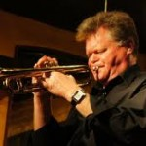 Steve McDade

One of the world’s “go-to” jazz trumpeters, Steve McDade has a collection of Junos and Grammys over the last three decades as a result of his participation in groups like Manteca, and Rob McConnell and the Boss Brass. He’s shared stages with the likes of Ray Charles, Aretha Franklin, Ella Fitzgerald, Diana Krall, and has been recorded on a hundred albums. Add in hundreds of radio and TV jingles, programs, and stage credits like Miss Saigon, Les Miserables, and Chicago….well, that doesn’t cover the half of it!

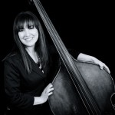 Jodi Proznik

A Vancouver-based, Juno-nominated bassist, composer, bandleader, and educator, Jodi Proznick has earned a reputation as one of Canada’s finest jazz artists. She has won numerous National Jazz Awards, including Bassist of the Year in ’08 and’09. Her group, the Jodi Proznick Quartet, was awarded the Acoustic Group of the Year and Album of the Year in ’08. She’ll be performing throughout the festival: at the opening Jazz Dinner, with the Bob DeAngelis Quintet, and at the Miles Davis Kind of Blue show with trumpeter Steve McDade. She’ll also play after-hours jam sessions and the Sunday morning Jazz Mass.

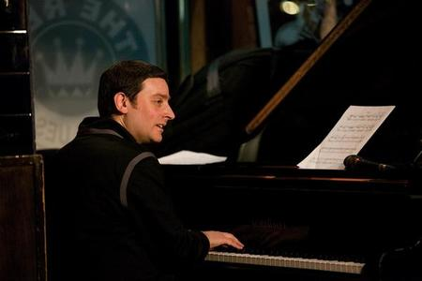 David Restivo

David Restivo is a three-time National Jazz Award winner (pianist of the year), and is well-known for his work with Rob McConnell's The Boss Brass and Tentet, the Mike Murley Quintet, and legendary songwriter Marc Jordan. He co-leads his own quintet, is a member in about ten more, and teaches at Humber College. David will join Guido Basso, Shakura S’Aida, and Neil Swainson on stage on Friday, Aug. 14 at the Regent Theatre.

Shakura S’Aida

A truly international artist who calls Canada home, Shakura was born in Brooklyn, raised in Switzerland, and is a long-time resident of Toronto. She’s appeared in New York’s famed Apollo Theater, and in the past two years alone, her soulful voice has delighted audiences from the Caribbean to Moscow, from Dubai to Romania, from Macedonia to Austria…to name just a few! Possessed of a rare ability to connect with audiences, she is featured with the legendary Guido Basso on the main stage Friday Aug. 14.

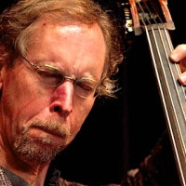 Neil Swainson

A regular fixture on the Toronto jazz scene with a resume that includes Rob McConnell, Moe Koffman, George Shearing, Lee Konitz, Slide Hampton, and many more…Neil Swainson leads his own quintet and lists more than a dozen other elite jazz groups he’s a member of. He’ll be playing in the Regent Theatre show on Friday Aug. 14 featuring Guido Basso, Shakura S’Aida and David Restivo.

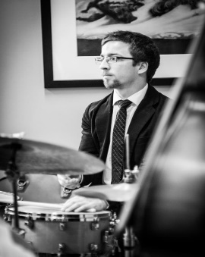 Ian Wright

Ian was the Festival’s 2011 Rising Young Star winner. Born in Belleville and now based in Toronto, Ian has performed locally, nationally and internationally with various groups and artists including: Autobahn, I Double You, Hawksley Workman, Kellylee Evans, David Occhipinti Trio, Nancy Walker Quintet, Shannon Gunn Quartet, Mara & The Marigold, CADE, Midcoast, and the Andrew McAnsh Quintet.. Ian will be drumming for the Miles Davis Kind of Blue show on Thursday Aug. 13 at the Regent Theatre.

